Task 0: Best Bubbles Investigation

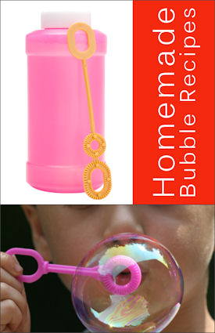

Outcomes: Science inquiry

AIM: To find out which mixtures is the best for blowing bubbles

- Follow the instructions below to make bubble mix.

- 120mls of water
- 40 mls of detergent
- 40 mls of glycerol

Mix together all ingredients. Add a few drops of food colouring to help you see the bubbles. This is your control mixture. Your task is to adjust the mixture to see if you can improve it. You have to decide how you will measure the standard of the bubble mixture.
Measurement of Control Mixture: ______________________(unit)

Trial 1: _____________________

Trial 2: _____________________

Trial 3: ____________________

- Select one variable to change, so that you can see its effect.

I will change _____________________________________________________________

- Write a hypothesis (What do you think will happen? Try to relate the variable that you changed to the results that you expect.)

_____________________________________________________________________________________________________________________________________________________________________________________________________________________

- Make up your experimental mixture and test it. Repeat three times each and record the results in a table, including the control data.

Title:

Heading: | Heading:
Heading: | Trial 1 | Trial 2 | Trial 3 | Average

5. Think about the type of data that you recorded. What type of graph suits this data?

_______________________________________________________________________

- Graph your results below:
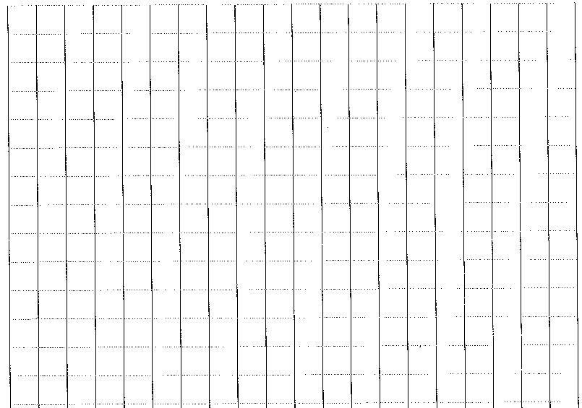

- What is your independent (changed) variable and how did you measure it?
___________________________________________________________________________________________________________________________________________

- What is your dependent (effect) variable and how did you measure it?
______________________________________________________________________________________________________________________________________________

- List three controlled variables that you had to keep the same to make your experiment a fair test.
_____________________________________________________________________________________________________________________________________________________________________________________________________________________

- What happened and why? Describe and explain any trends in your results.
___________________________________________________________________________________________________________________________________________________________________________________________________________________________________________________________________________________________________________________________________________________________________

- Did you have any difficulties or problems with your experiment?
____________________________________________________________________________________________________________________________________________________________________________________________________________________________________________________________________________________________

- How would you fix this problem if you did this experiment again?
____________________________________________________________________________________________________________________________________________________________________________________________________________________________________________________________________________________________

- Write a conclusion for your investigation. (What was the overall finding? Was your hypothesis supported or not supported?)
_____________________________________________________________________________________________________________________________________________________________________________________________________________________

 |  | Mark Allocation | Mark
Hypothesis | - Hypothesis relates independent and dependent variables | 1
Variables | - Independent variable is identified  - Dependant variable is identified  - 1-3 controlled variables identified | 5
Results | - Table includes title which relates variables  - Columns relate to independent and dependent variables  - Columns have headings  - Headings include units | 4
Graph | - Graph title relates variables  - Graph type appropriate for data  - Axis correct orientation and labelled, including units  - Appropriate size and scale | 4
Discussion | - Results summarised and trends identified  - Explanation of results using scientific knowledge  - Difficulties or sources of error identified  - Suggestions for improvement | 4
Conclusion | - Summary of findings  - Hypothesis supported or not. | 2
Total
/20

